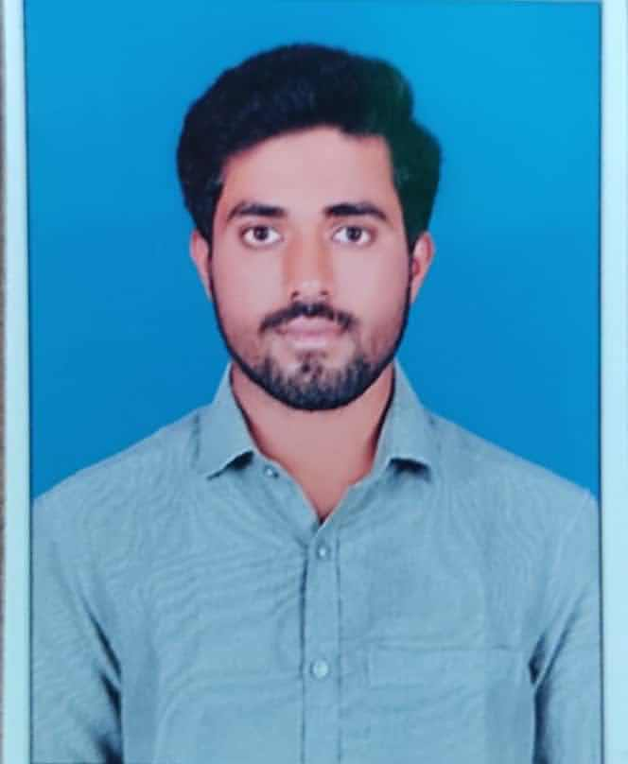

VEERADINESH PERUGU

Career Objective

To get an opportunity where I can make the best of my potential and contribute to the organization’s growth where I can learn new skills,expand my knowledge, and leverage my learnings.



[dineshperugu956@gmail.co m](mailto:dineshperugu956@gmail.co%20m)

8688920398



69,Godiganuru(v),Chagalamarri(m),Nandhyal district. Andhrapradesh.

# SKILLS

Python programming

**EDUCATION**

Basics of C programming language

## Bachelor of technology

### K.S.R.M College Of Engineering

*12/2020 - 06/2024*, *Kadapa, Andhra Pradesh*

*Courses*

Electronics and communication engineering with 73%

## Intermediate

### M.G.M junior college

*06/2018 - 03/2020*, *Srikalahasthi, Andhra Pradesh*

*Courses*

MPC with 88%

## SSC

### Gautam High School( with 90% )

*06/2017 - 04/2018*, *Proddatur, Andhra Pradesh*

Ms word

# INTERNSHIP

Problem solving skills

Successfully completed the International Internship In Advance certiﬁcation on Emerging Technologies (Robot operating system) oﬀered by APSSDC

Adaptability skills

(08/2022 - 10/2022)

Communication skills

# PROJECT

## Age and Gender detection by machine learning

# LANGUAGES

English

*Full Professional Proﬁciency*

Telugu

*Full Professional Proﬁciency*

Hindi

*Limited Working Proﬁciency*

# CERTIFICATES

Completed Hackerrank python basic certiﬁcation course

Received python programming certiﬁcate from pantech-e-learning Received Python course completion certiﬁcate oﬀered by Great learning

# INTERESTS

**ACHIEVEMENTS**

Prathibha award from state government

Watching cricket

Playing Volleyball